5 Dial Function Garden Hose Pipe Water Nozzle Spray Gun

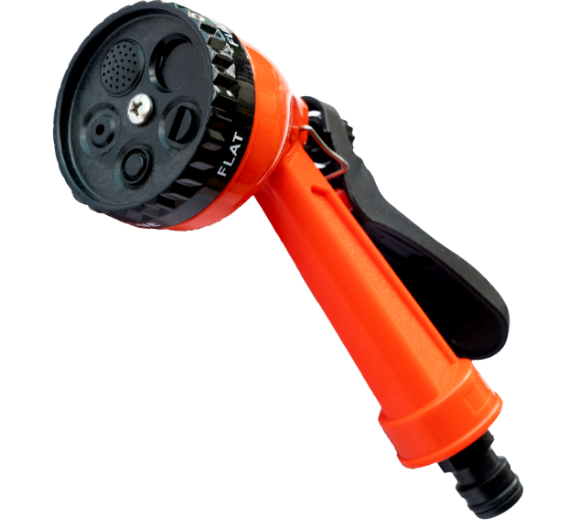
MULTIFUNCTIONAL: This Garden Spray gun has 5 multi-functional watering settings,Prefect for patio, lawn, garden watering and car wash etc.

- Comfortable grip for contoured fit
- Lockable handle for continuous spray
- Rotating header 5 dial water pattern
- Made from ABS plastic which is frost resistant & shatter proof.
- Part number: LMS140502
- Barcode number:8400800041142

